**Lab2**

**Name: Aya Allah Ali Track: System Admin**

**1)**

**- check where is the location of archivelog**

**archive log list;**

This command displays a list of all archived redo log files that are available for database recovery. The information displayed includes the name of each archived redo log file, the date and time it was created, and the archive log destination it was written to.

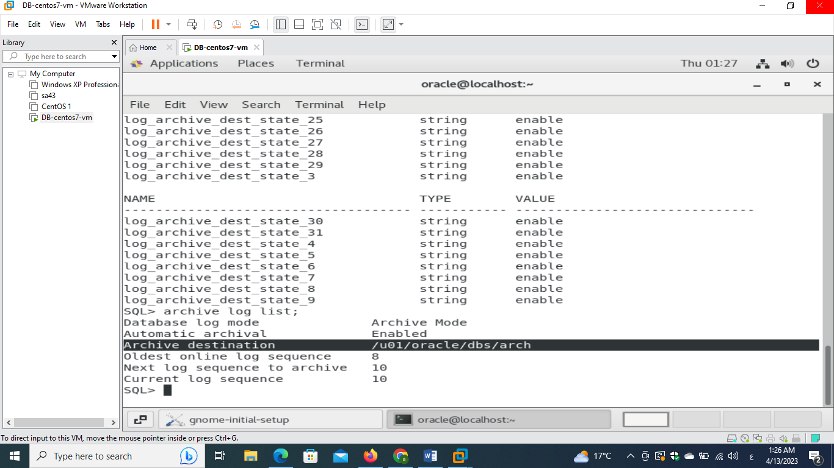

**- switch online redo log file by command**

**SELECT * FROM V$LOG;**

This command will display information about all redo log files in the database, including their group number, sequence number, status, size, and other attributes.

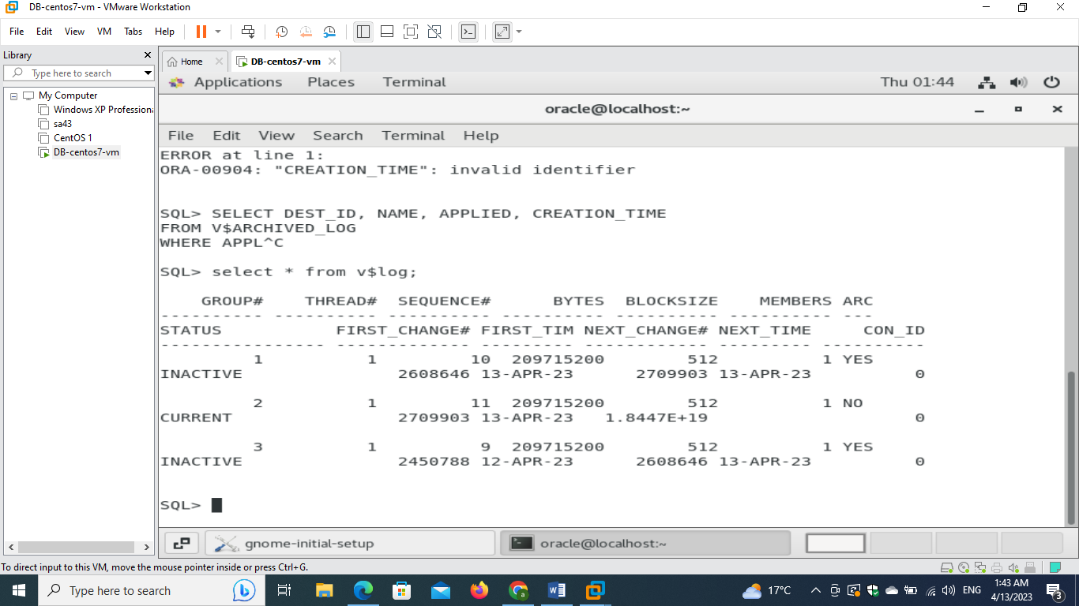

the ALTER SYSTEM SWITCH LOGFILE command, Oracle performs the following steps:

1. Writes all modified database blocks in memory to the current online redo log file.
2. Marks the current online redo log file as inactive and unavailable for writing new redo log entries.
3. Switches the redo log target to the next available redo log file in the current redo log group.
4. Marks the new online redo log file as active and available for writing new redo log entries.

**ALTER SYSTEM SWITCH LOGFILE;**

This command will switch the current online redo log file to the next available redo log file in the redo log group.

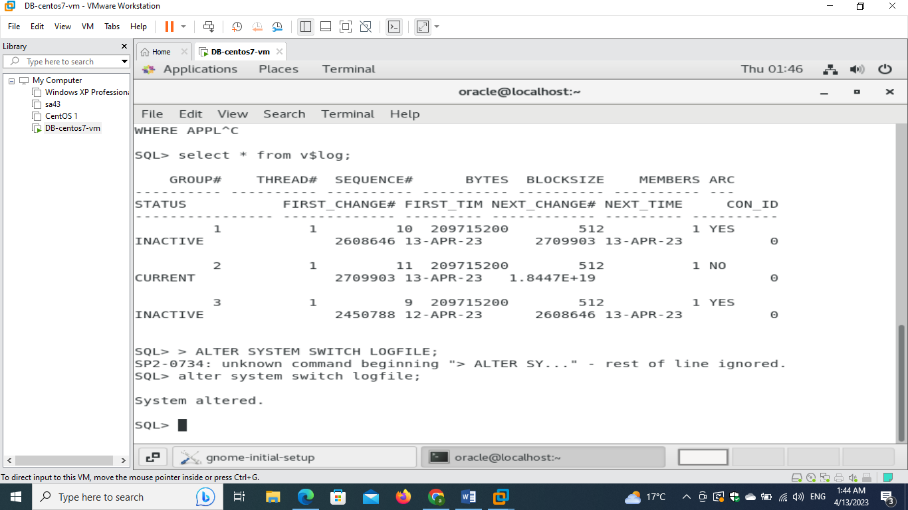

**SELECT * FROM V$LOG;**

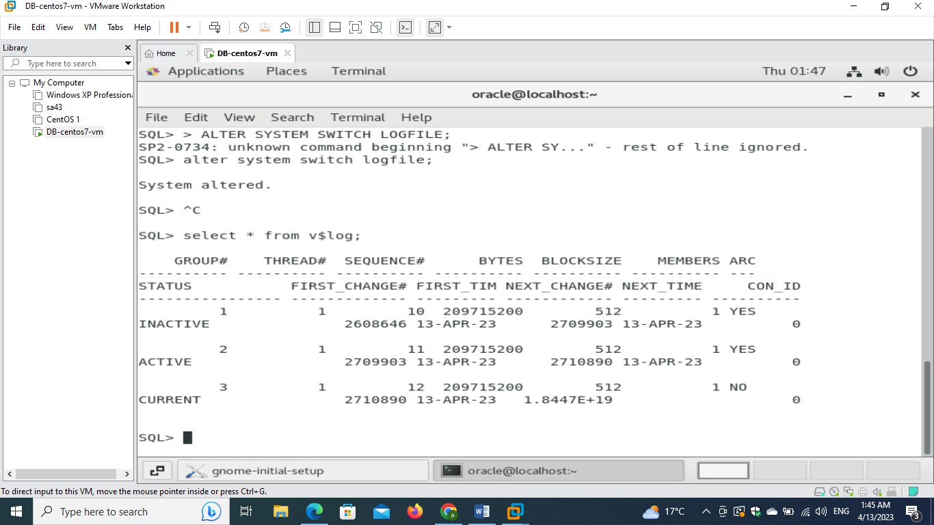

**- select group , archived, status from v$log ;**

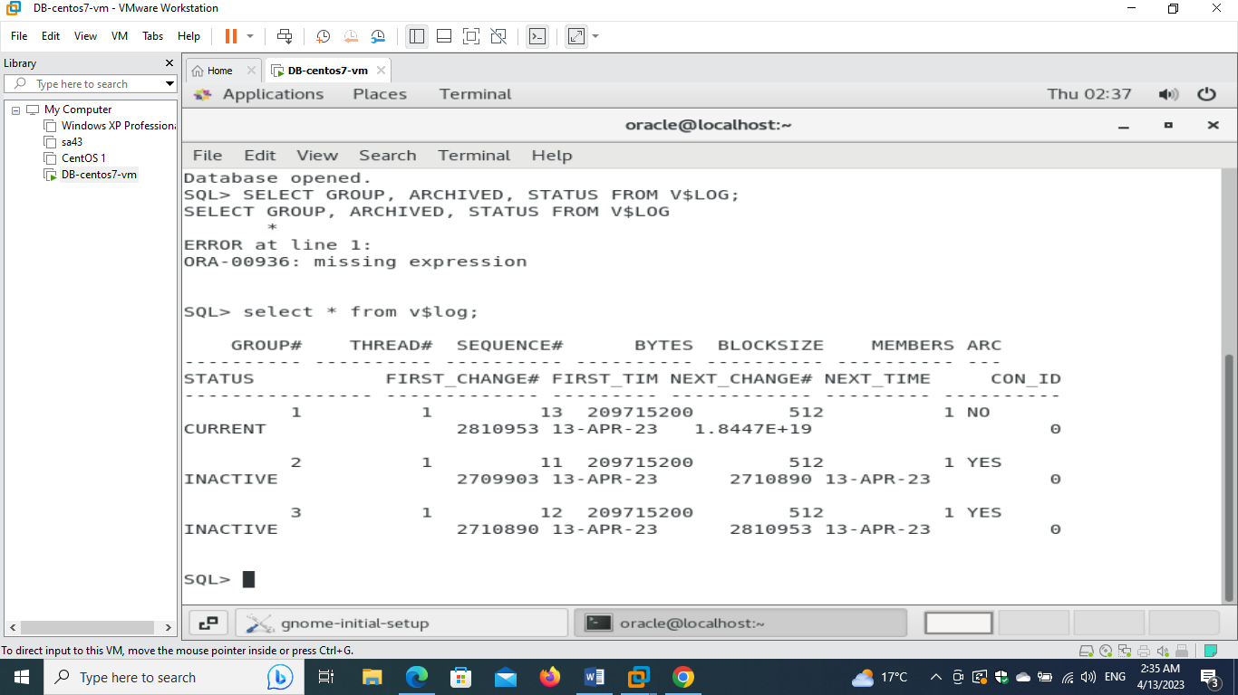

**- view the redo log files names, size, group number, status, archived or not and their sizes in MB using the views "v$log" and "v$logfile".**

**Desc v$log;**

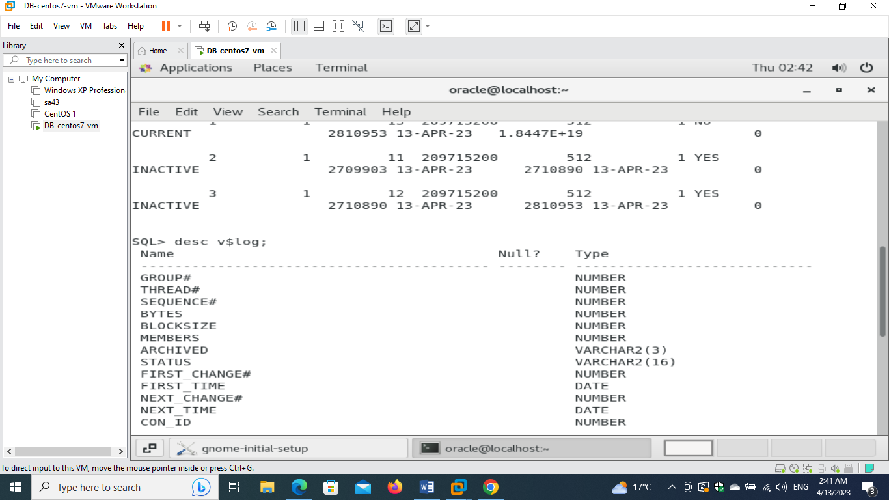

**select GROUP#, BYTES, MEMBERS, ARCHIVED, STATUS from v$log;**

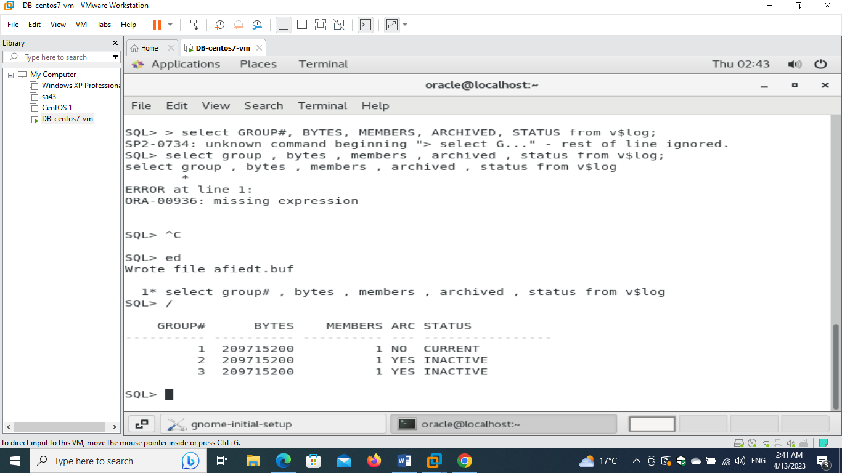

**Desc v$logfile;**

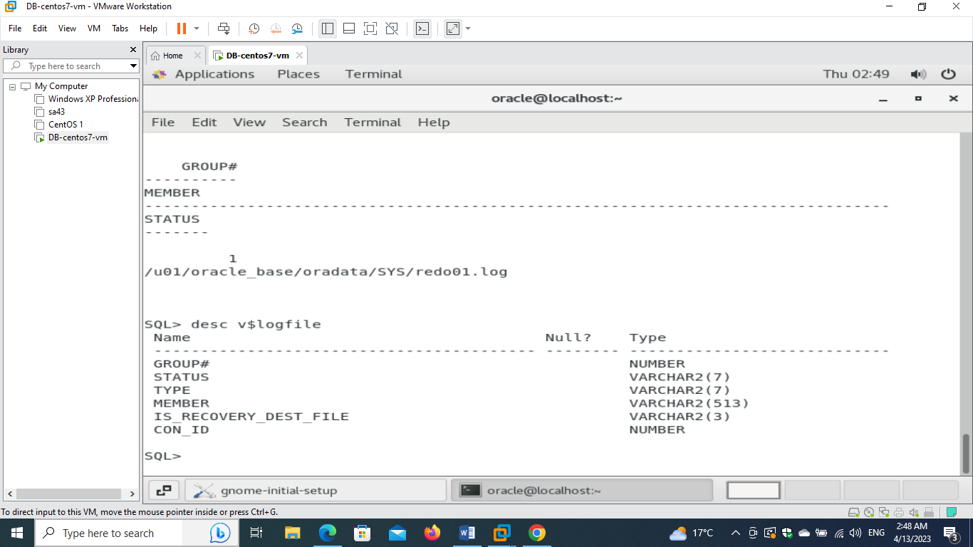

**select GROUP#, STATUS, MEMBER from v$logfile;**

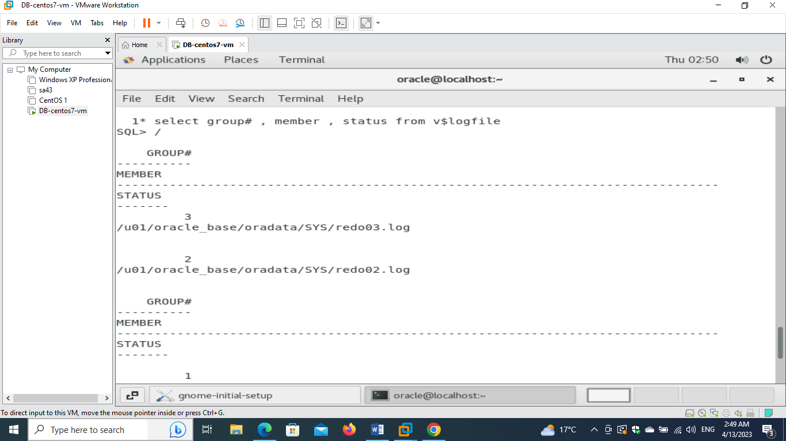

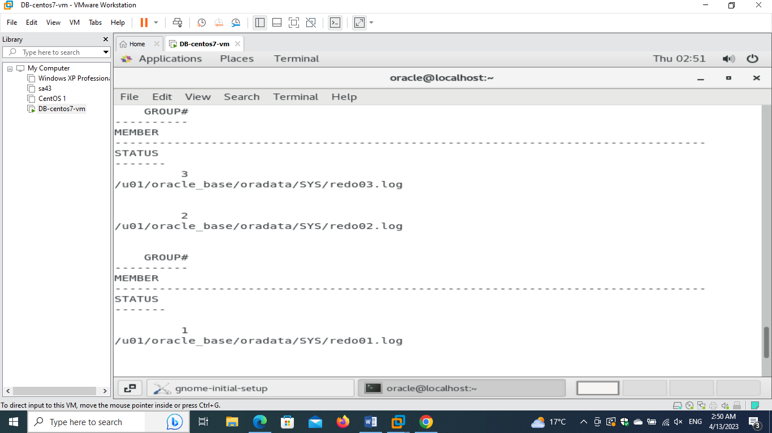

**- Increase the size of all redo log files to be 100 MB, then repeat the last step. ( google it please )**

**select GROUP#, BYTES/1024/1024, MEMBERS, STATUS from v$log;**

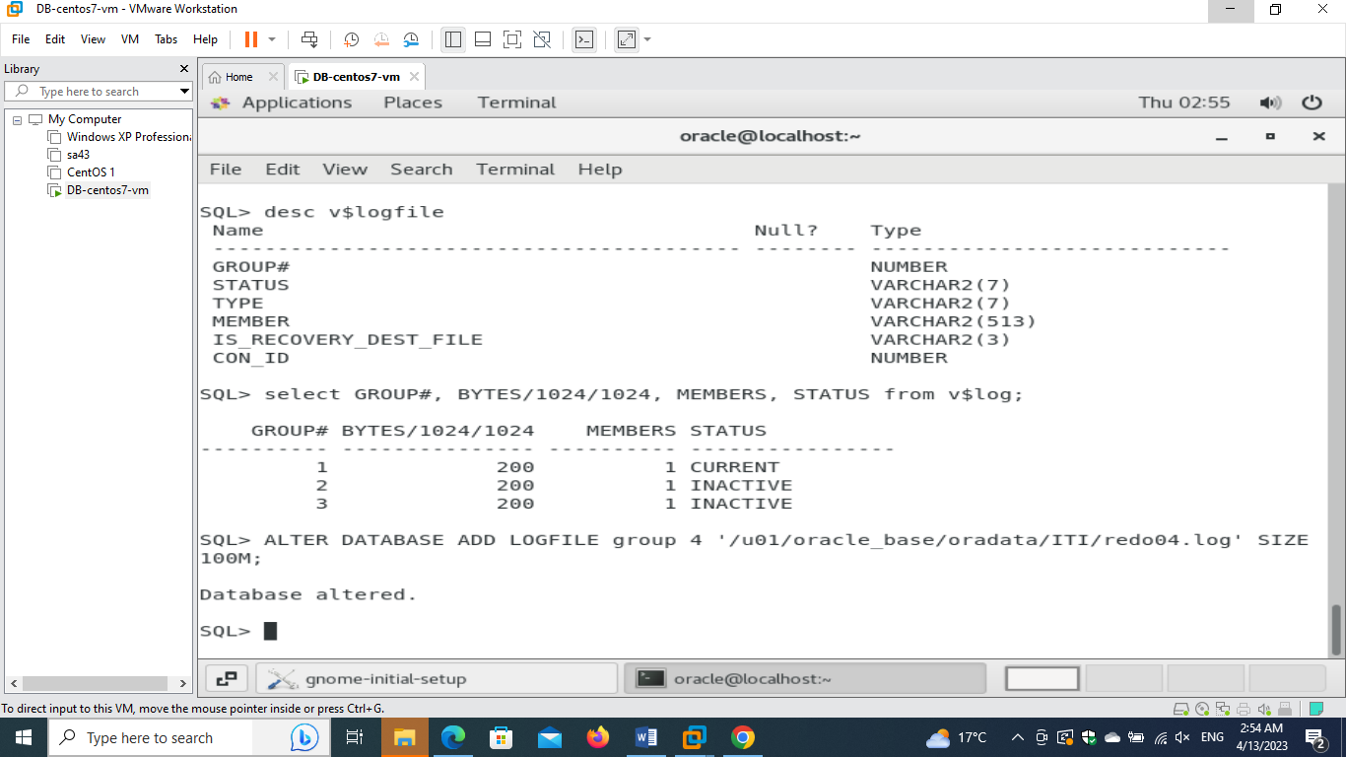

**select GROUP#, BYTES, MEMBERS, ARCHIVED, STATUS from v$log;**

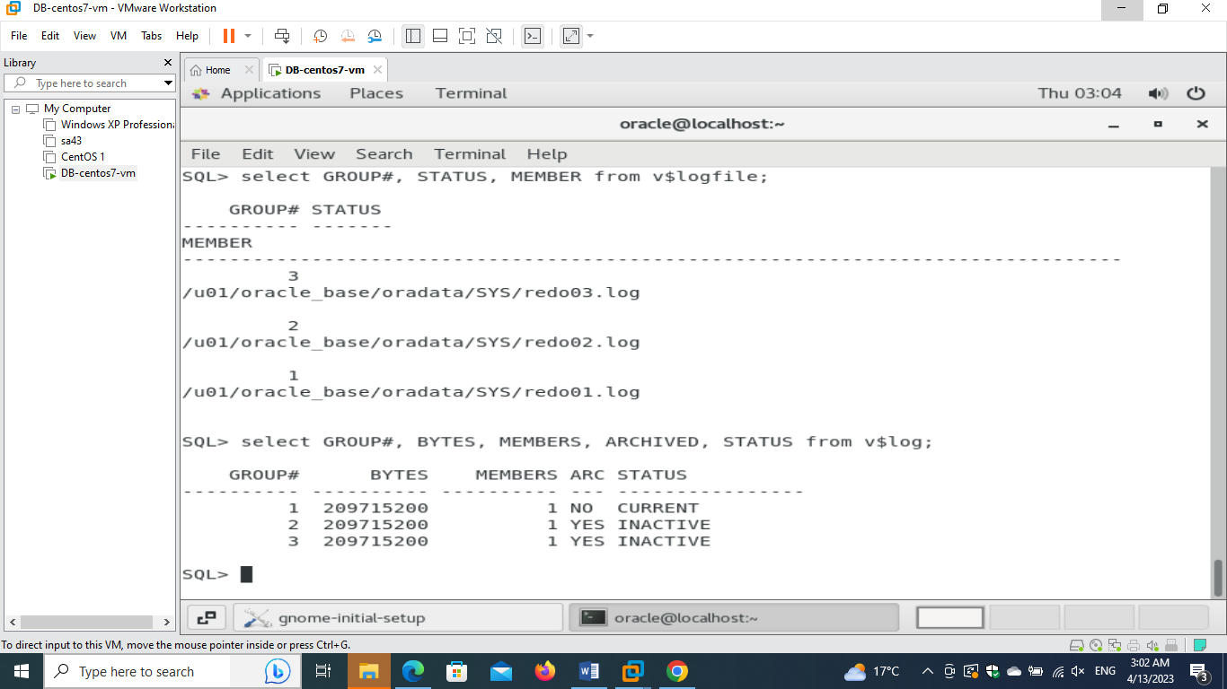

**select GROUP#, STATUS, MEMBER from v$logfile;**

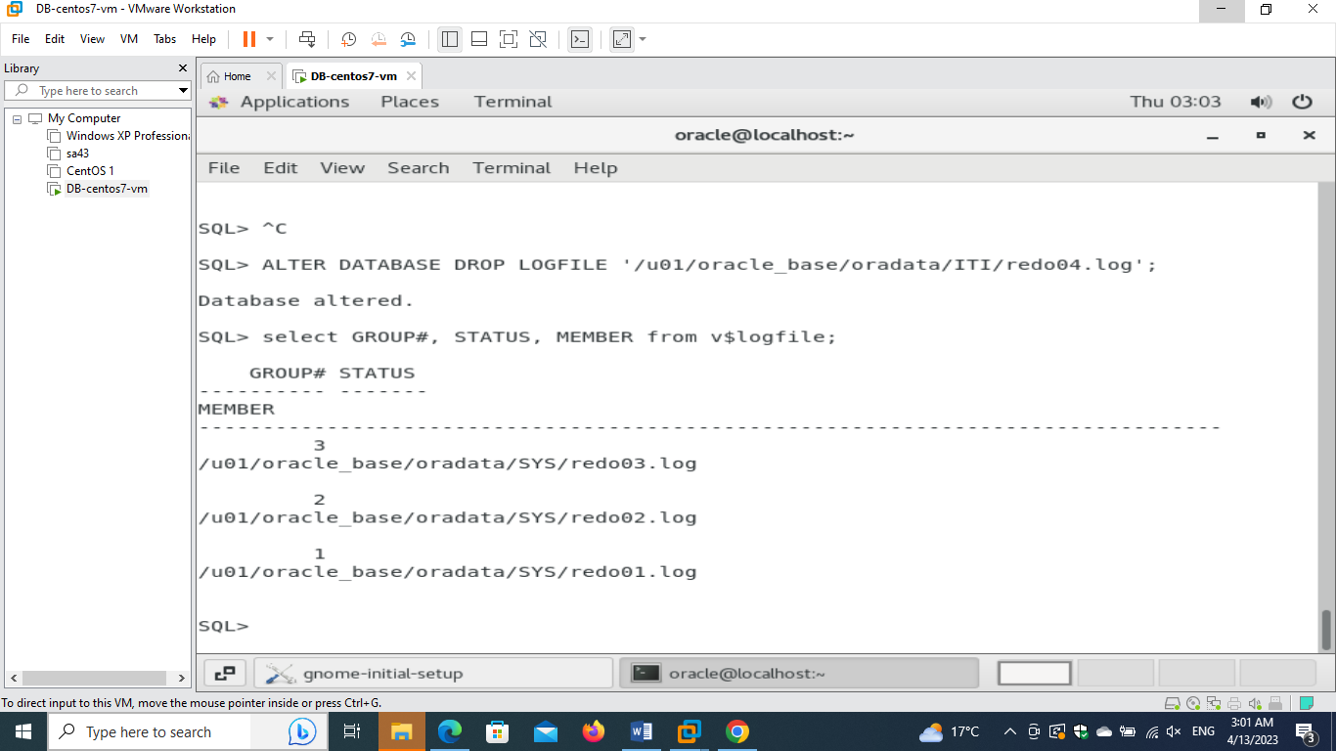

**Adding new groups 11,22,33 and dropping group 1,2,3 (I needed to use**

**ALTER SYSTEM SWITCH LOGFILE; to be able to drop the group)**

**I used this method as the size of groups 1,2,3 was 200M so shrinking the size (decreasing the size to 100M) wouldn’t work as there will be loss in data**

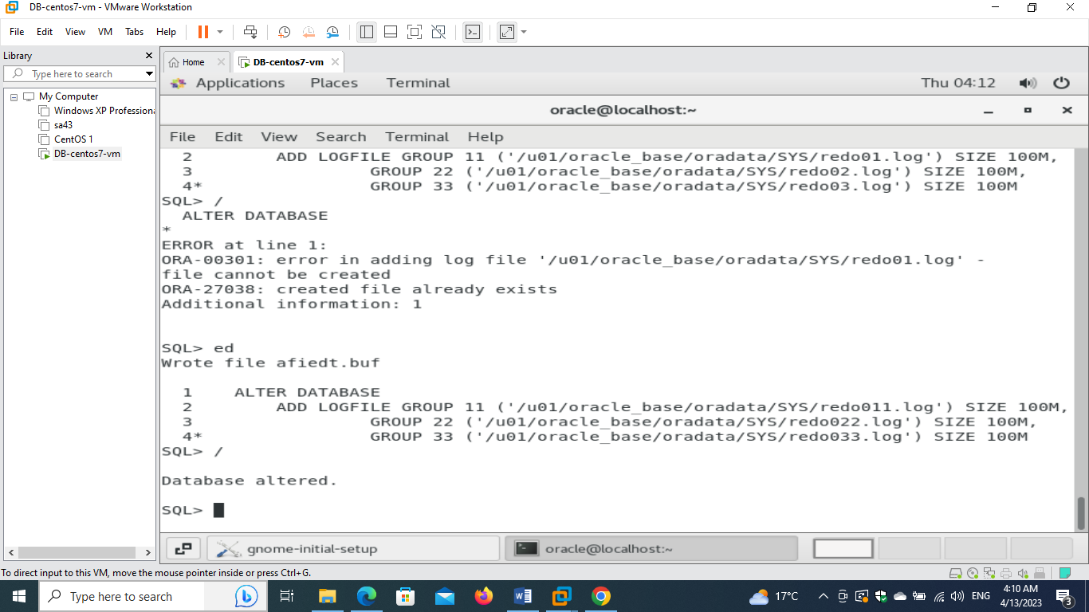

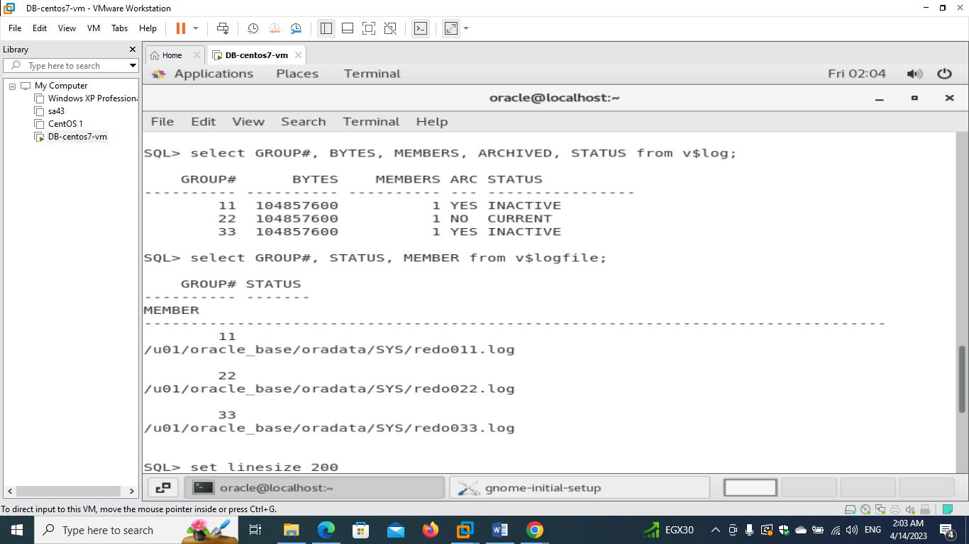

**- create new three redo log file groups 4,5 and 6 ( google it please ) then again view the redo log files names, size, group number, status, archived or not and their sizes in MB using the views "v$log" and "v$logfile"**

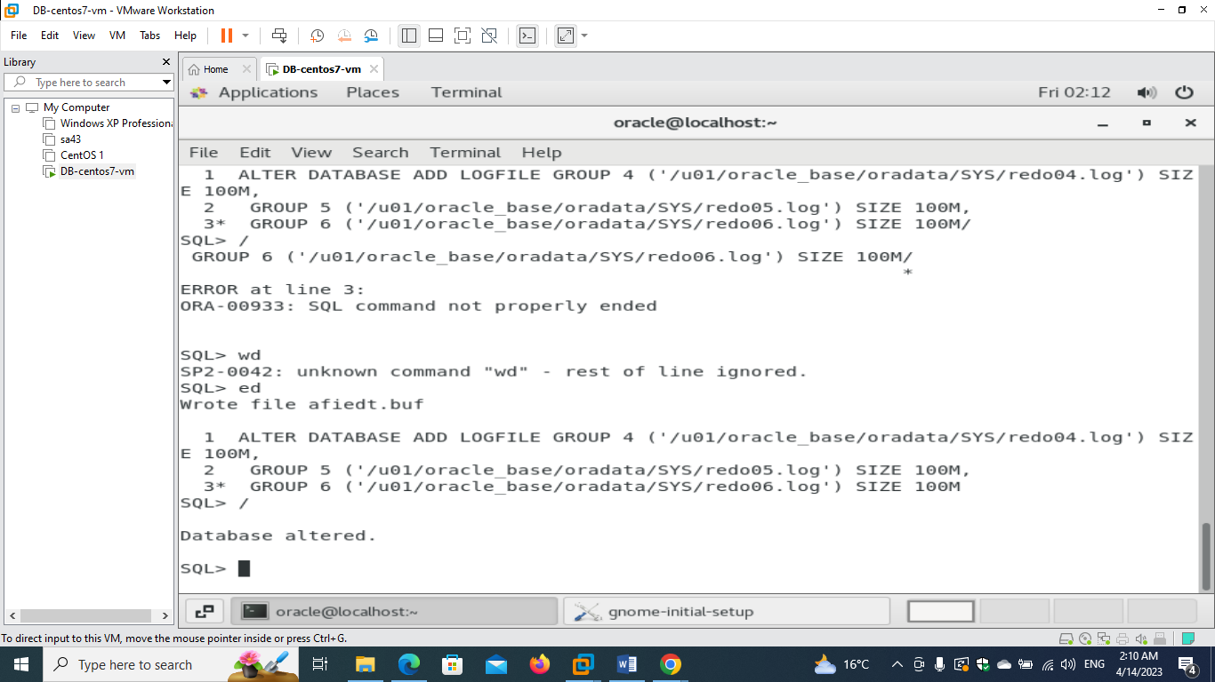

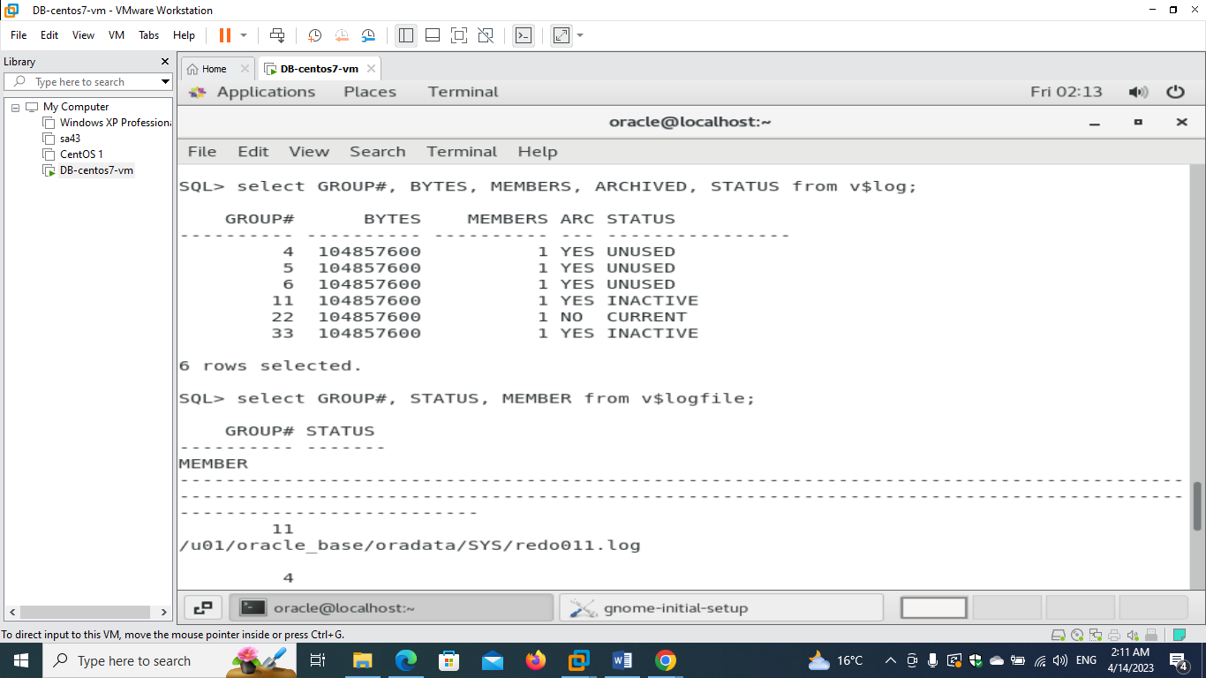

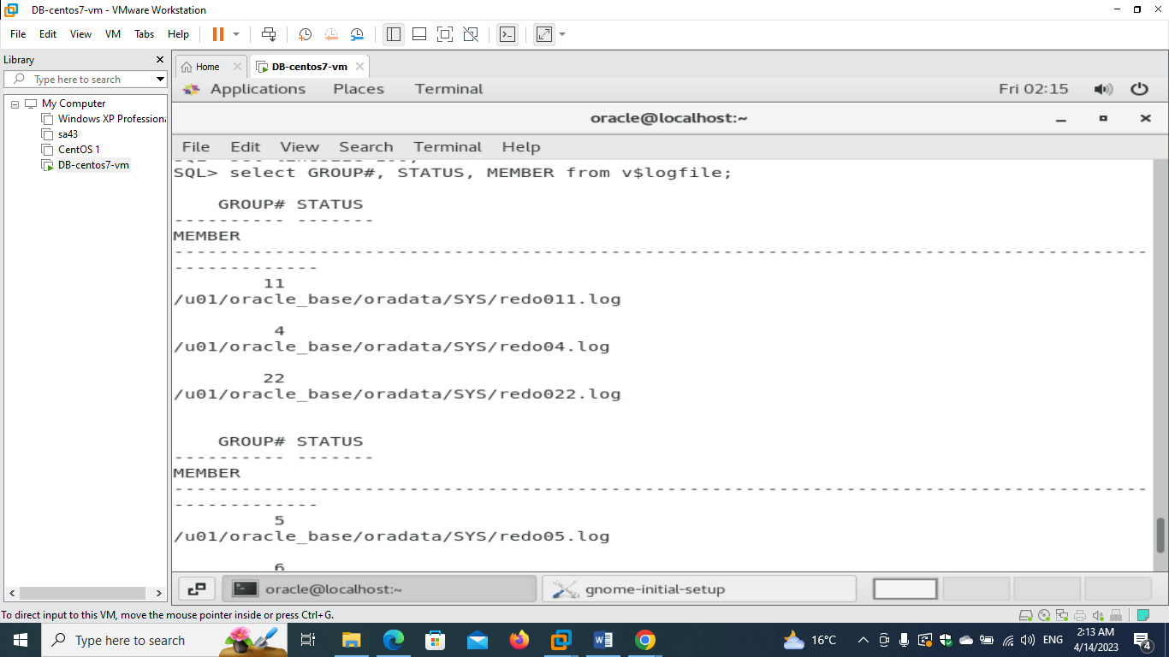

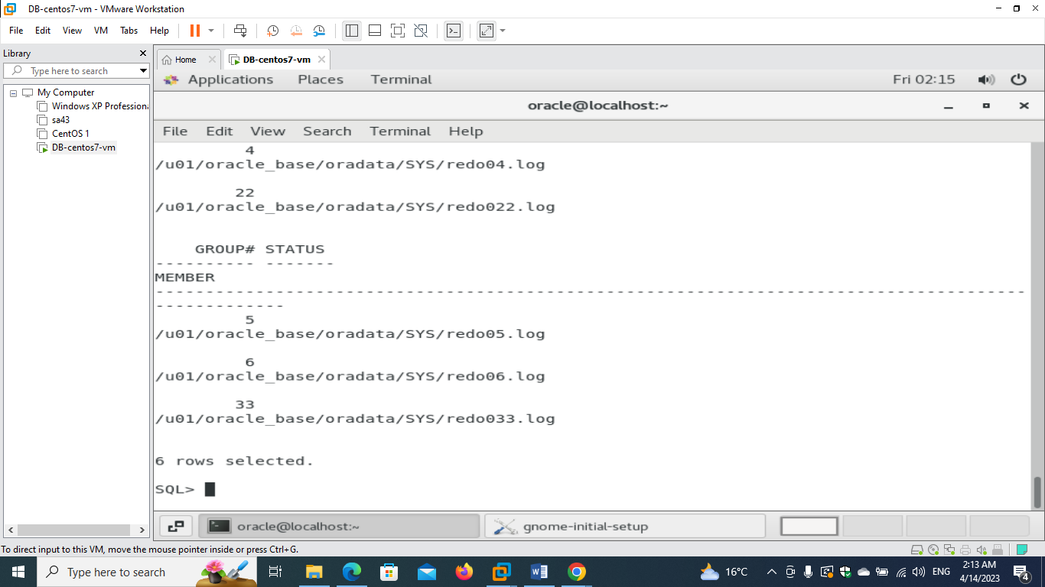

**- drop redo log group 6 ;**

**Make sure the group was still not used**

**Or (inactive and archived)**

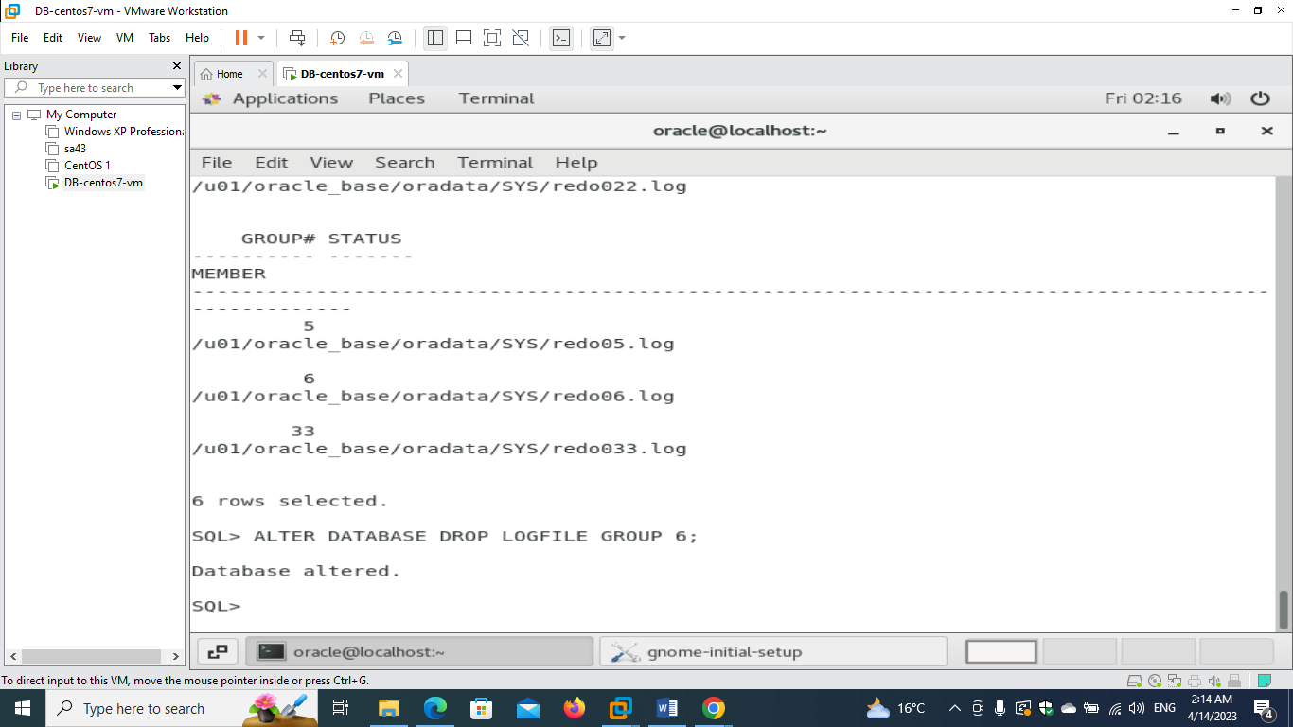

**2)**

**- create new undo tablespace , with one datafile 50MB**

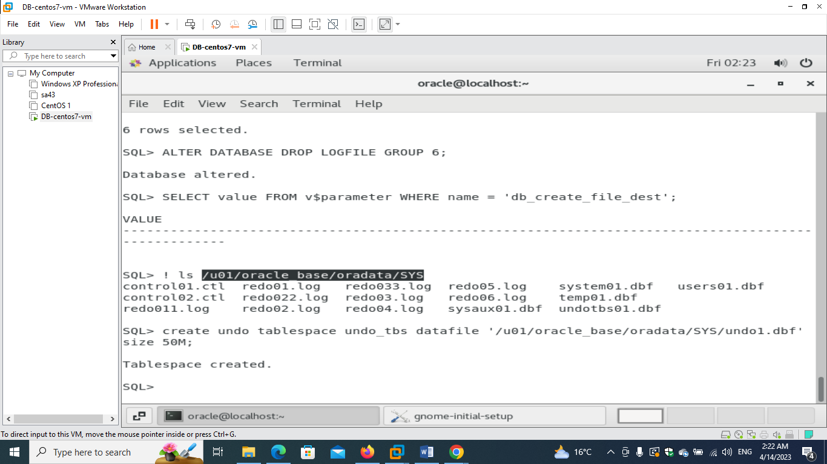

**- Show the value of parameter undo_retention then change the value of it to be 3 minutes and gurantee this duration.**

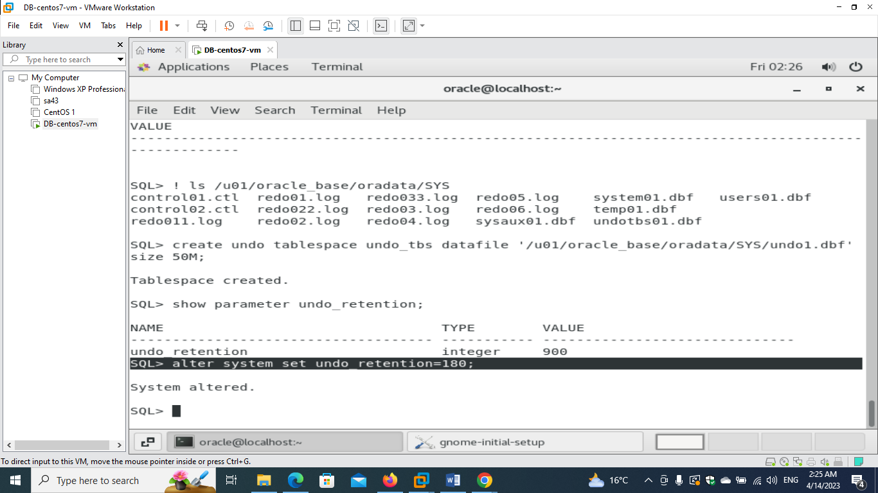

**SELECT tablespace_name, retention FROM dba_tablespaces;**

**ALTER TABLESPACE undo_tbs RETENTION GUARANTEE;**

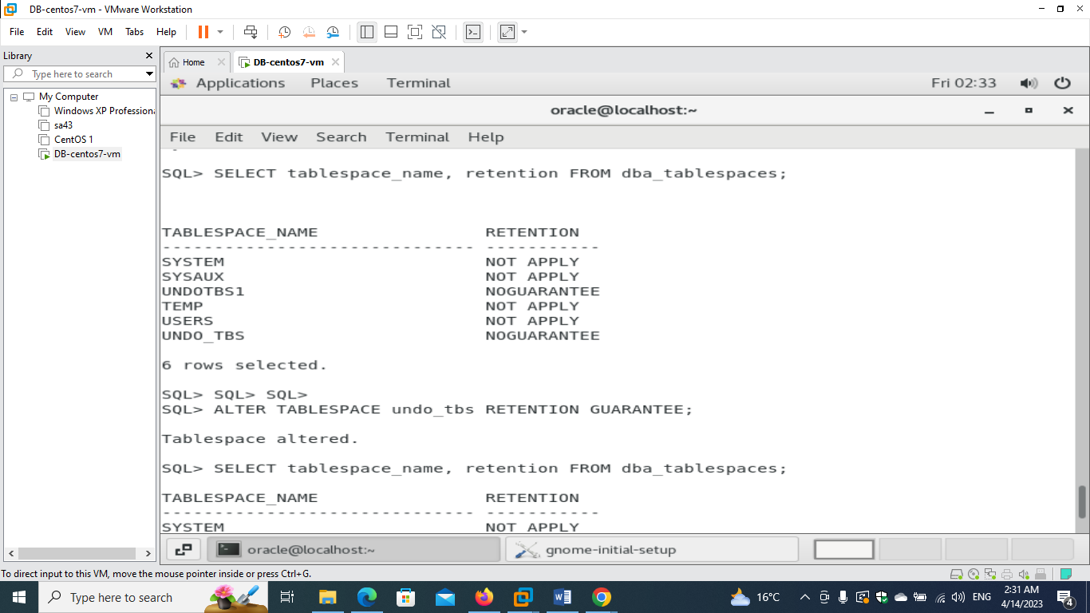

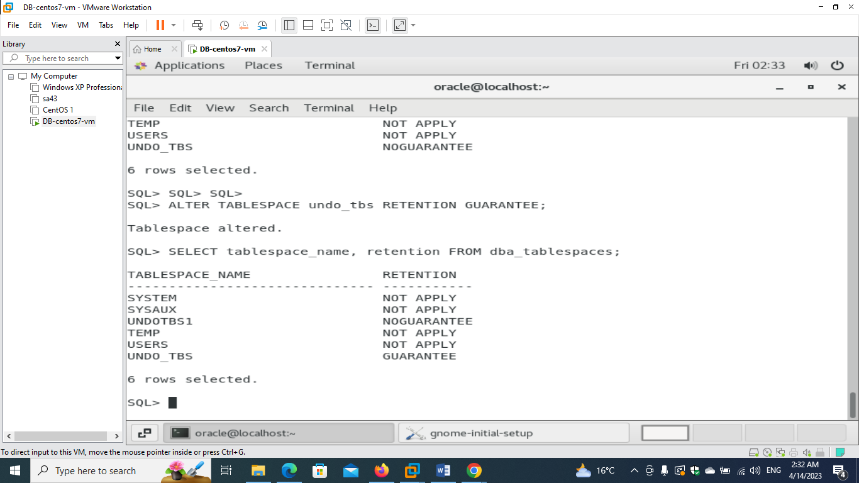

**- make this new created tablespace the default tablespace**

**Alter System SET Undo_Tablespace=undo_tbs;**

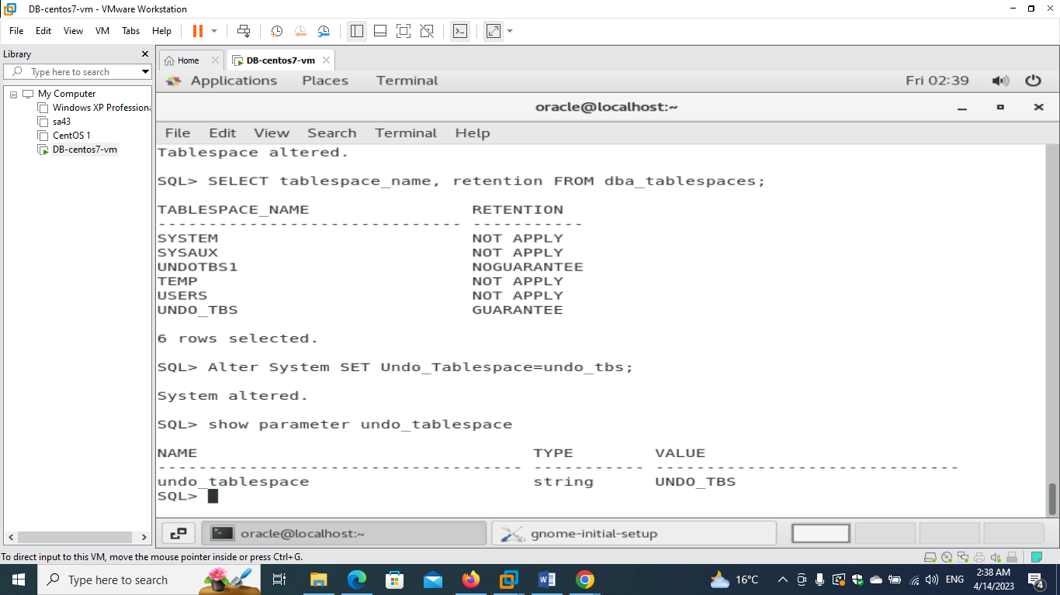

**- create new tablespace ITI with one datafile with size 50MB and make it the default tablespace for HR user**

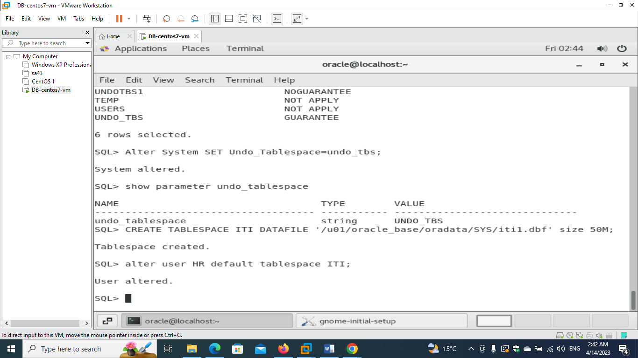

**- create temporary tablespace TEMP2 with size 50MB**

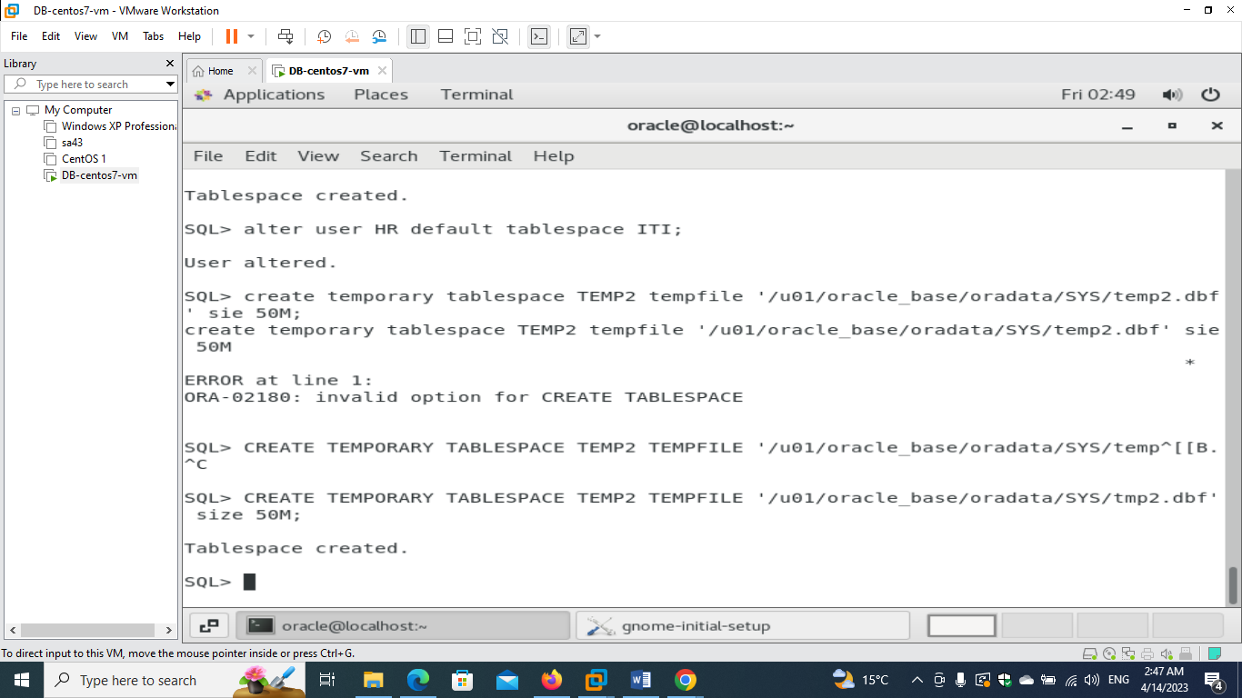

**- resize up the datafile of ITI tablespace from 50MB to 100MB**

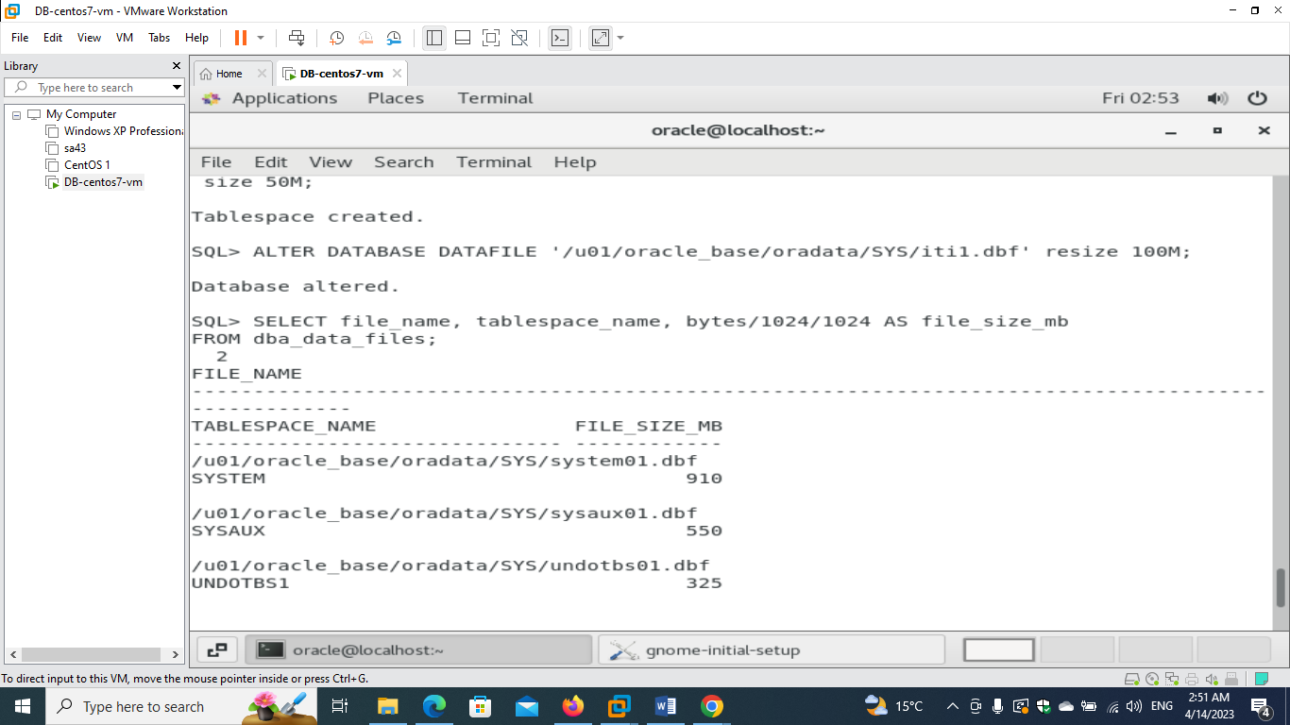

**- show data files names, thier tablespaces, their size, their status using view "dba_data_files".**

**SELECT file_name, tablespace_name, bytes/1024/1024 AS file_size_mb**

**FROM dba_data_files;**

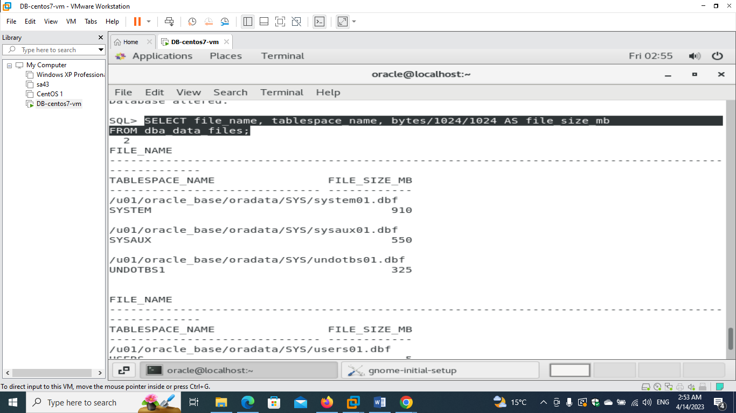

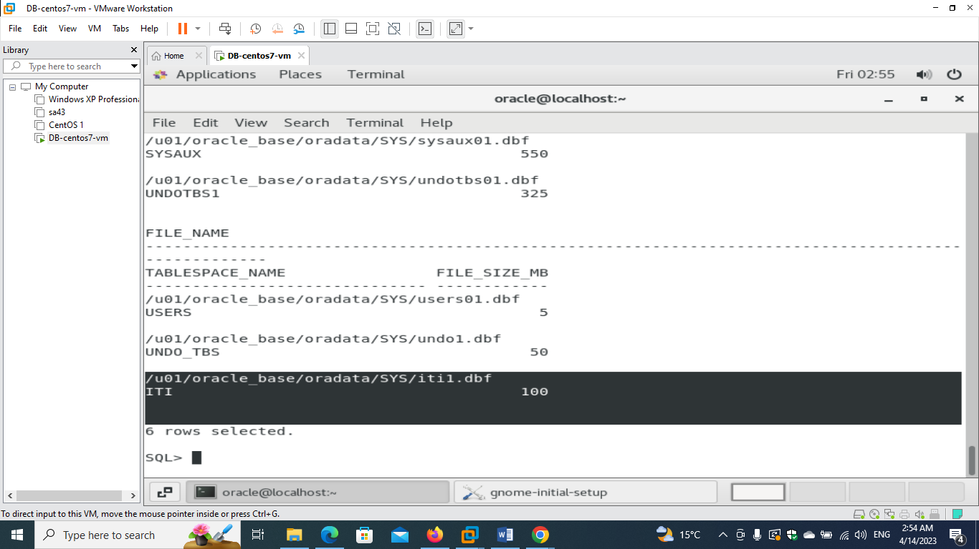

**3)**

**- create an OS user with name "iti" and make him login to the database using "sqlplus /"**

**Export variables to set the environment**

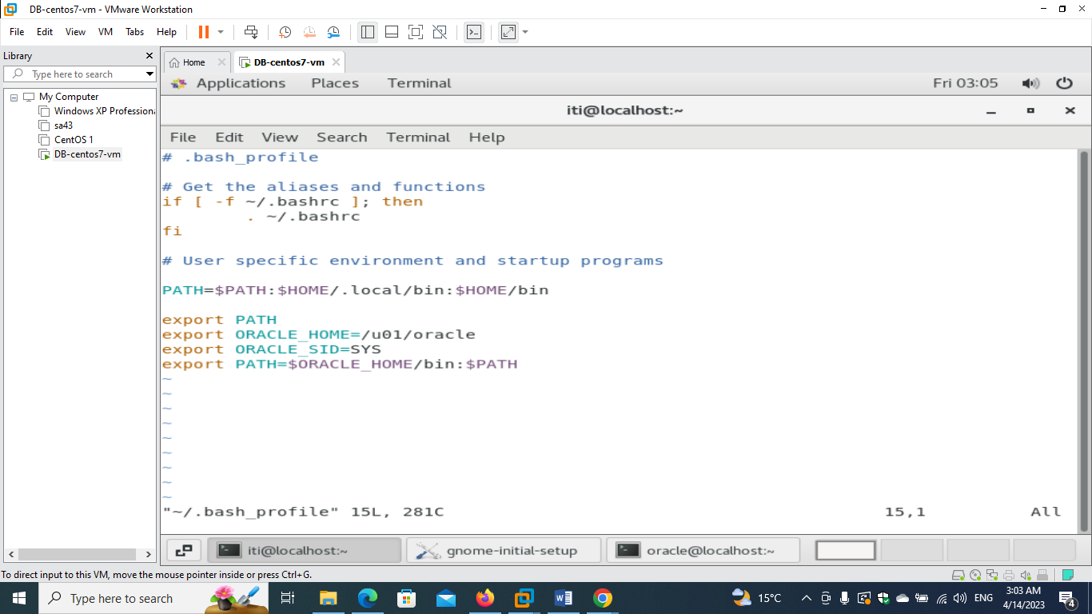

**Here I created datdbase user from os user with same passwd**

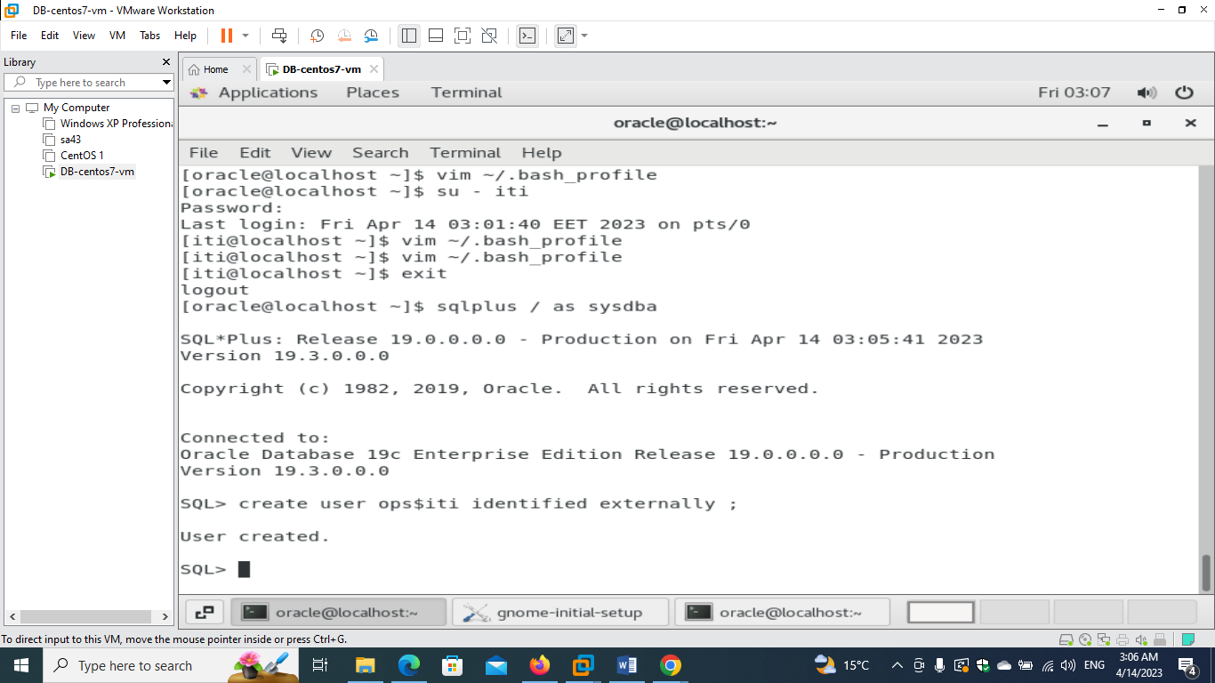

**Giving iti grant permission to open session**

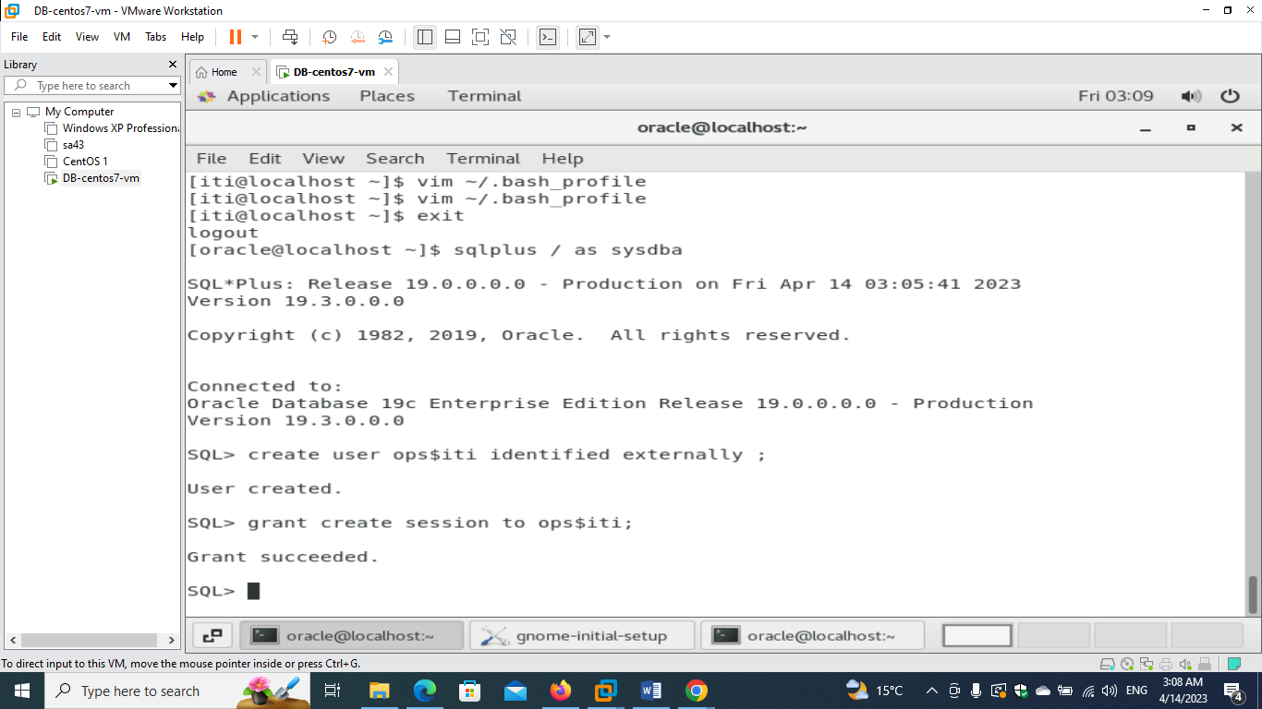

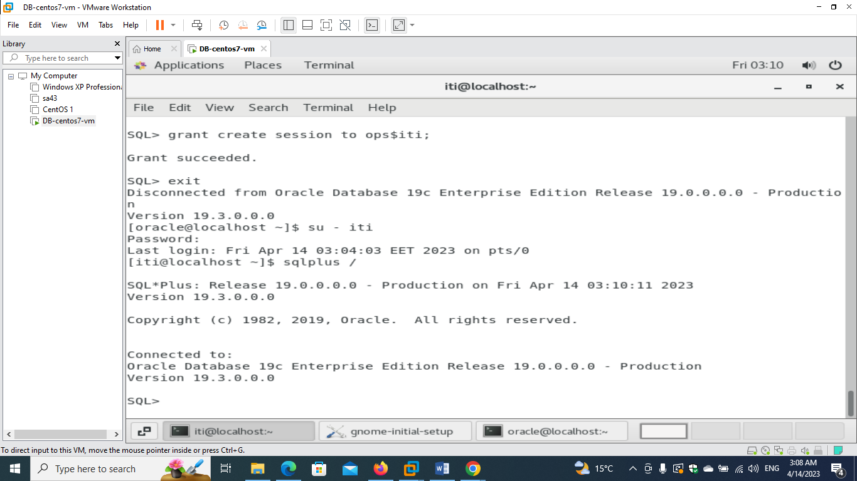

**- make your personal Operating system user to connect locally with authentication as sysdba.**

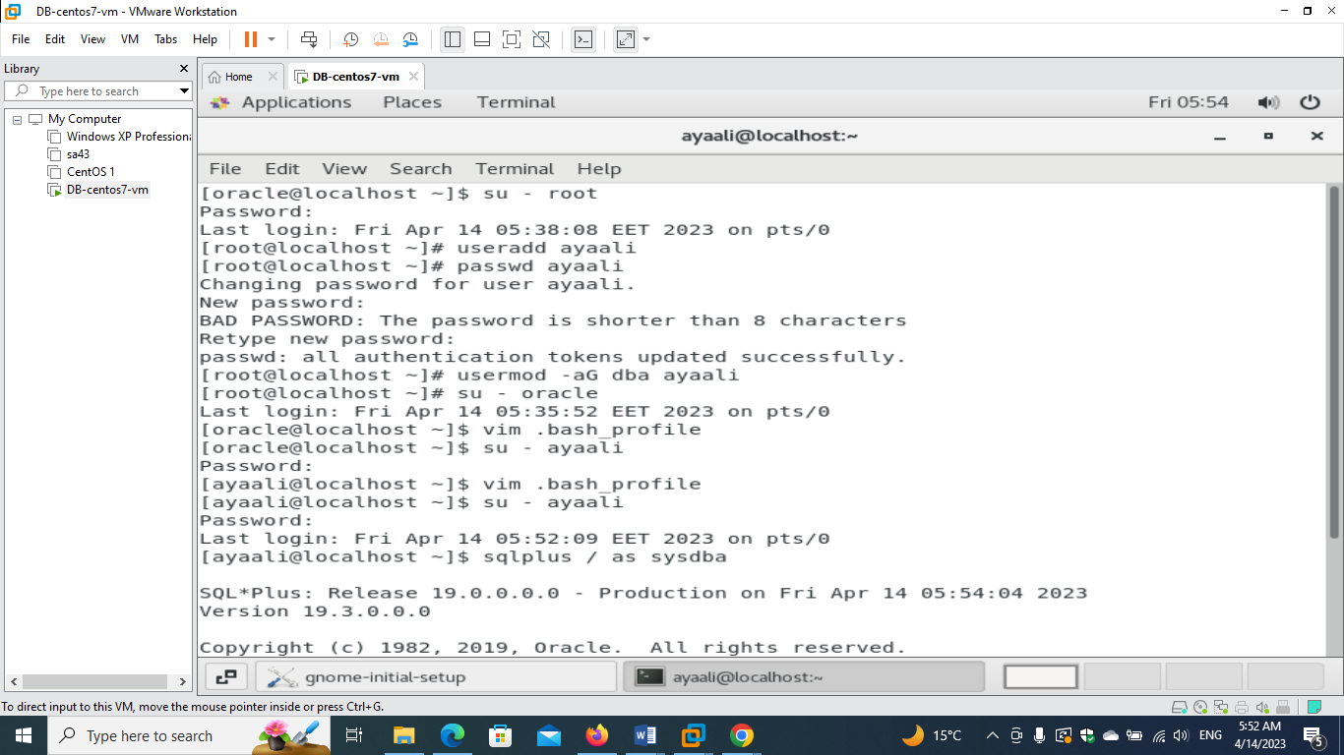

**Export needed variables in the new user ayaali**

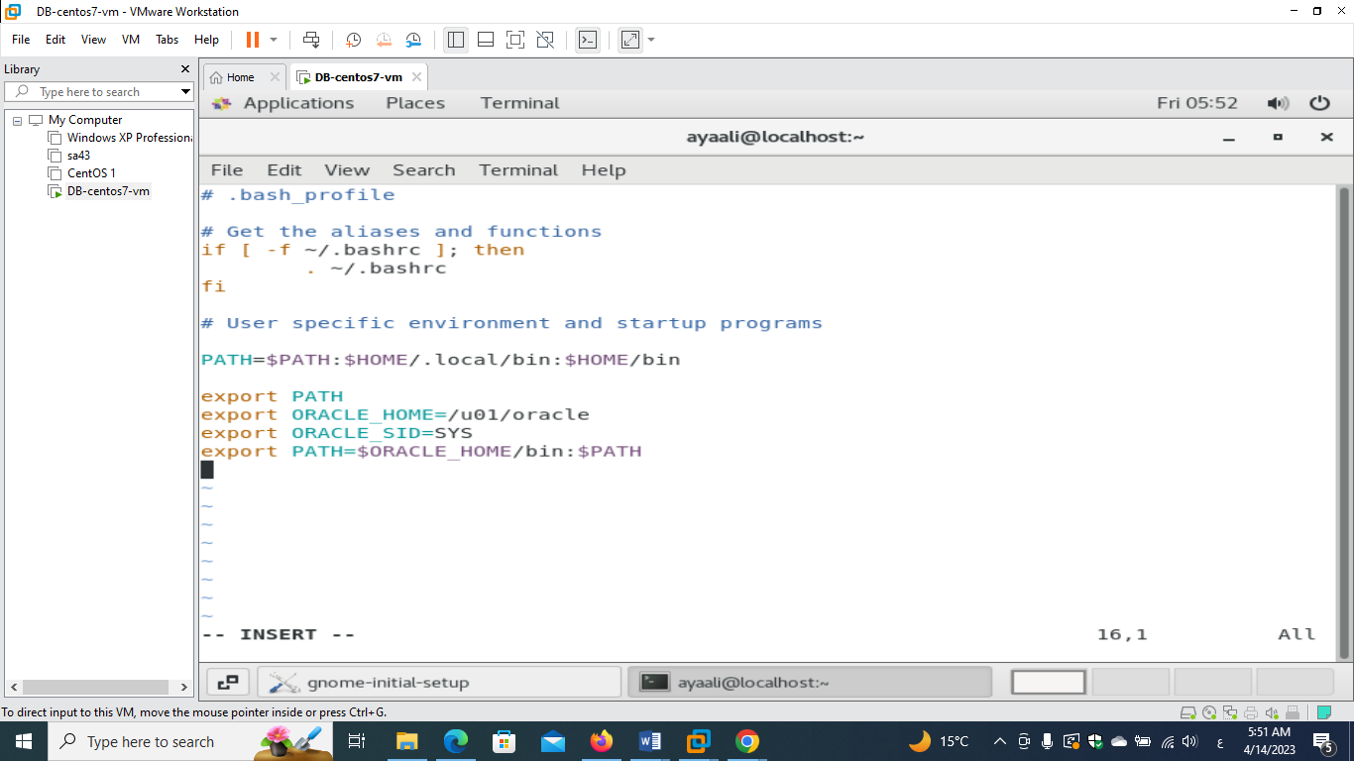

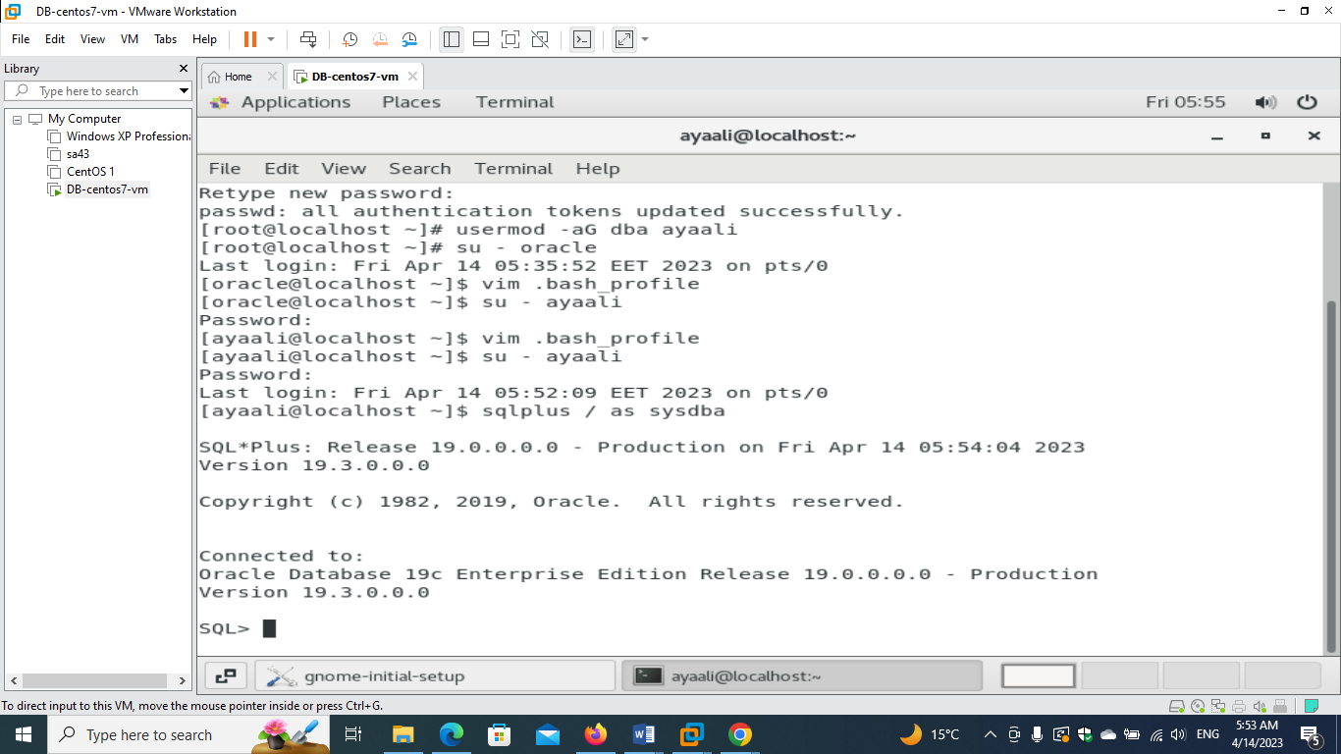

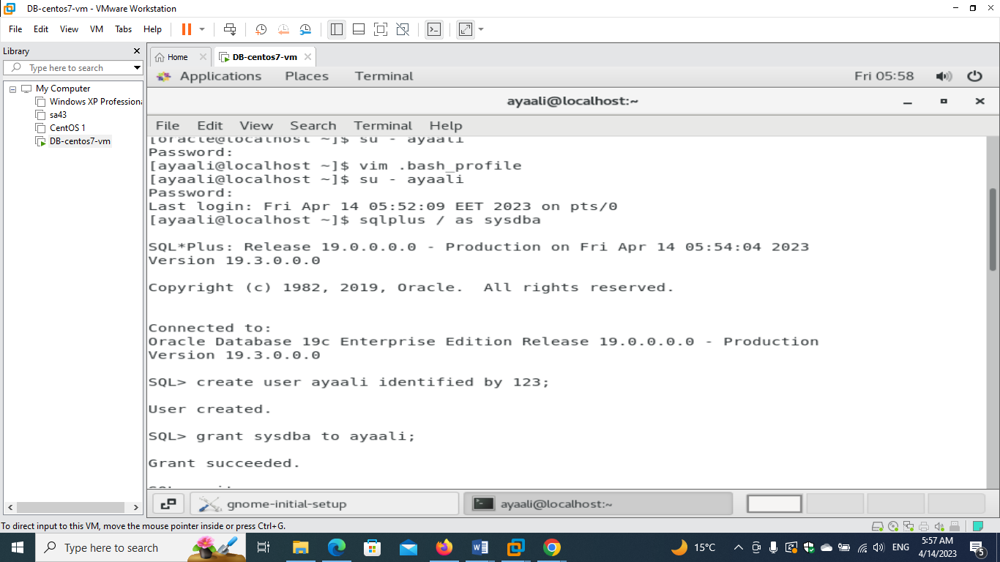

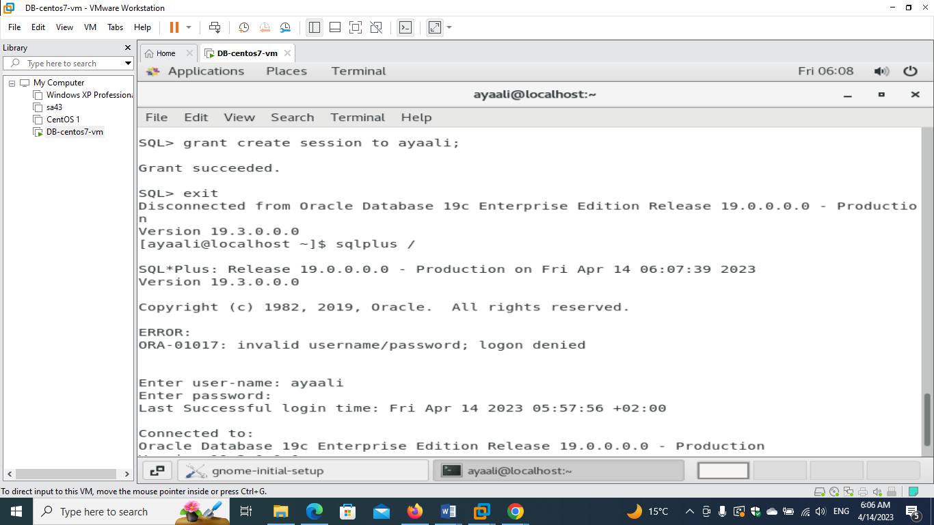

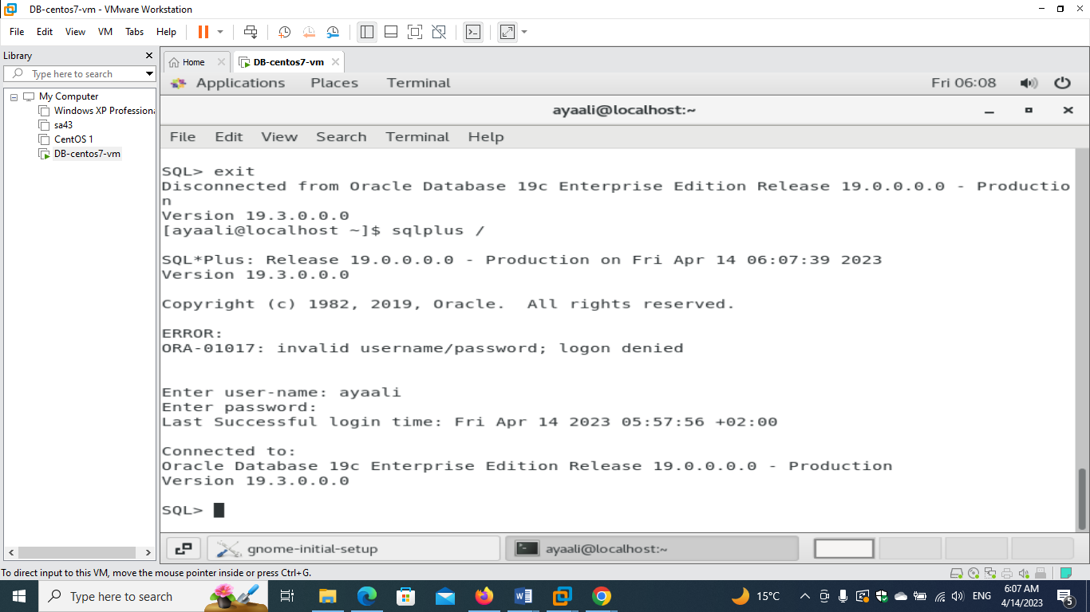

**Extra part for me 😊**

**Without grant create session user ayaali couldn’t connect the database**

**So I also tried different method and gave dba role to user ayaali**

**Which has less privileges than sysdba but managed to connect without the need to grant create session**

